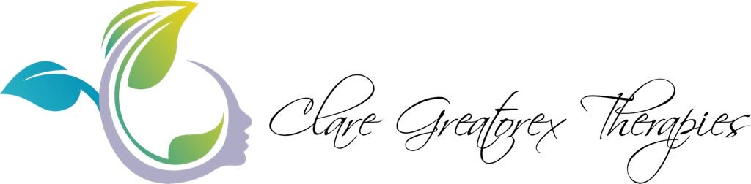

Privacy Policy
This notice tells you what information I hold, why I hold it and what your rights are.
When you attend one of my courses, or have a treatment with me, I will gather and retain information which is relevant and which will enable me to provide a professional and holistic service. Some of this information will relate to your health and wellbeing and may be of a sensitive nature. All of this information will remain confidential and will only be used in connection with the treatments and/or courses I provide.

What information do I collect about you?
I collect information about you when you register for a course or attend a treatment with me. I do not collect any personal identifying information without your knowledge.
When you attend a course or treatment, I will hold information which includes:
- Contact details,
- Medical history and other health-related information.
- Treatment details and related notes which I take after an initial consultation and during ongoing sessions.
To comply with insurance requirements, your information is stored in a locked cabinet and will be kept for up to 7 years following your last treatment session or course attendance. Once this time has passed, all information will be shredded and destroyed.
Your information will not be shared with anyone else without first explaining why it is necessary and gaining you explicit consent.
However, it may be necessary to share your information and any health-related concerns I have with other healthcare professionals e.g. your GP. The reasons for this may be if your health has deteriorated since your last treatment session or if a specific symptom has increased in severity and is difficult to manage.

Cookies
Please be aware that my website uses cookies and although this does help to provide an improved user experience, cookies does retain user preferences and provide anonymised tracking data to third party applications such as Google Analytics.
If you would prefer not to use cookies, you can disable this at any point via your browser.

Third Parties
None of your information is passed on to third parties without your consent except where required to do so by law.

Marketing
I would like to send you information about special offers and promotions which may be of interest. I may also need to change or re arrange appointment times. Please indicate how you would like to be contacted at your initial treatment session or when you register to attend a course. This will then be documented in your treatment notes or on your registration form.

Access to your information
You have a right to access any personal information I hold about you and to have any inaccuracies corrected.
Please address requests to the GDPR Officer: Clare Greatorex, The Orchard, High Street, Blagdon BS40 7TQ
or e mail info@claregreatorex.com
Full details of your rights can be found at https://ico.org.uk/for-organisations/guide-to-the-general-data-protection-regulation-gdpr/individual-rights/.

Safeguard of Information
I am committed to ensuring that your personal data is secure. To prevent unauthorised access or disclosure, I have put in place technical, physical and managerial procedures to safeguard and secure the information I collect from you.

